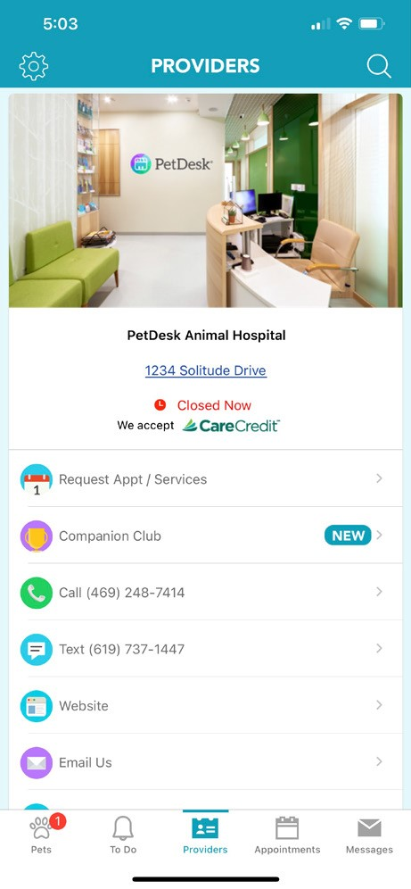
Prioritize Your Pet’s Health with the free PetDesk Mobile App
Request and confirm appointments with all your pet care providers
Refill medications • Access pet health records • Text your practice
Create reminders for recurring pet health tasks.
Download Here!
Join our Pet Parent Rewards Loyalty Program
Earn 2 paw points for every dollar spent and redeem for cash off professional services.

