Dental Disease Stages
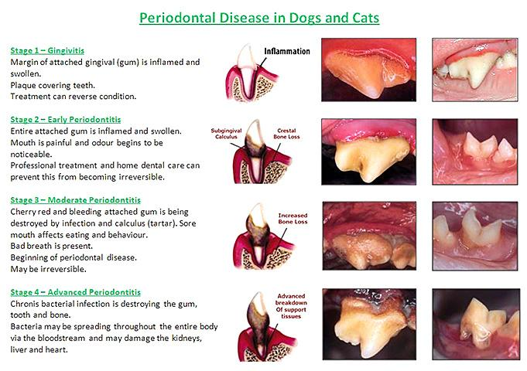

Stage 1- Most likely just cleaning, giving a range in case of extractions.
Stage 2- Heavier tarter, some extractions expected.
Stage 3- Heavier tarter, with many extractions expected.
Stage 4- Horrible disease, numerous extractions needed.

